**11 b**

**Ferromagnetic materials**

There are various kinds of magnetism, out of which ferromagnetism is the strongest type. **Ferromagnetic materials** are those materials which exhibit a spontaneous net magnetisation at the atomic level, even in the absence of an external magnetic field.

When placed in an external magnetic field, ferromagnetic materials are strongly magnetised in the direction of the field. Ferromagnetic materials are strongly attracted to a magnet. These materials will retain their magnetisation for some time, even after the external magnetising field is removed. This property is called hysteresis.

# What Is Ferromagnetism?

Ferromagnetism gets its name from the word ‘ferrous’, which means iron, and it was

the first metal known to show attractive properties to [magnetic fields.](https://byjus.com/physics/magnetic-field/) Ferromagnetism is a unique magnetic behaviour that is exhibited by certain materials such as iron, cobalt, alloys, etc. It is a phenomenon where these materials attain permanent magnetism, or they acquire attractive powers. It is also described as a process where some electrically uncharged materials attract each other strongly. Ferromagnetism is a property that considers not only the chemical make-up of a material but also takes into account the microstructure and the crystalline structure.

# Causes of Ferromagnetism

In a ferromagnetic material in the unmagnetised state, atomic dipoles in small regions called domains are aligned in the same direction. The domains exhibit a net magnetic moment even in the absence of an external magnetising field. However, the magnetic moments of neighbouring domains are oriented in opposite directions.

They cancel out, and therefore the net magnetic moment of the material is zero. On applying an external magnetic field, these domains align themselves in the direction of the applied field. In this way, the material is strongly magnetised in a direction parallel to the magnetising field.

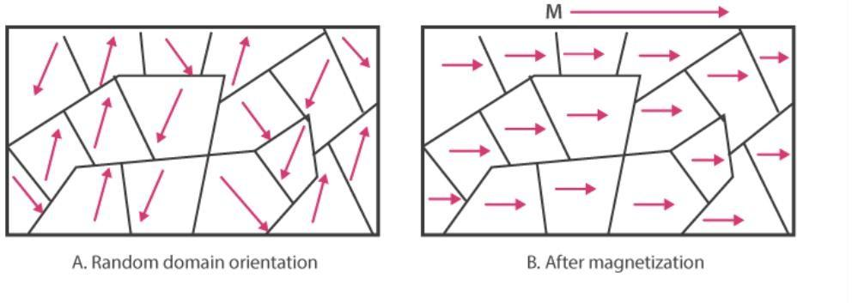

# Ferromagnetic Materials

Ferromagnetic materials are a certain group of substances that tend to manifest or display strong magnetism in the direction of the field due to the application of a magnetic field. The cause of magnetism in these materials is mainly due to the alignment patterns of their constituent atoms. These atoms tend to behave as elementary electromagnets.

# Examples of Ferromagnetic Materials

Most of the ferromagnetic materials are metals. Common examples of ferromagnetic substances are Iron, Cobalt, Nickel, etc. Besides, metallic alloys and rare earth magnets are also classified as ferromagnetic materials.

Magnetite is a ferromagnetic material which is formed by the oxidation of iron into an oxide. It has a Curie temperature of 580°C. Earlier, it was recognised as a magnetic substance. Magnetite has the greatest magnetism among all the natural minerals on the Earth.

# Properties of Ferromagnetic Materials

1. The atoms of ferromagnetic substances have permanent dipole moments present in domains.
2. Atomic dipoles in ferromagnetic substances are oriented in the same direction as the external magnetic field.
3. The magnetic dipole moment is large and is in the direction of the magnetising field.
4. The intensity of magnetisation (M) is very large and positive and varies linearly with the magnetising field (H). Hence, saturation depends on the nature of the material.
5. The magnetic susceptibility is very large and positive. Magnetic susceptibility Xm = M / H, where M is the intensity of magnetisation, and H is the strength of the applied magnetic field.
6. The magnetic flux density of the material will be very large and positive. Magnetic field lines become very dense inside ferromagnetic materials. Magnetic flux density B = **ε**0 (H + M), where ε0 is the magnetic permittivity of free space, H is the strength of the applied magnetic field, and M is the intensity of magnetisation.
7. The relative permeability is also very large and varies linearly with the magnetising field, and the field inside the material is much stronger than the magnetising field. They tend to pull in a large number of lines of force by the material.
8. Ferromagnetic substances are strongly attracted by the field. So, in a nonuniform field, they tend to stick at the poles where the field is strongest.
9. If a ferromagnetic powder is placed in a watch glass placed on two pole pieces which are sufficiently apart, then powder accumulates at the sides and shows depression in the middle because the field is strongest at poles.
10. When a ferromagnetic substance is liquefied, it loses ferromagnetic properties due to higher temperature.

# Hysteresis

On removing the external magnetic field, a ferromagnetic material doesn’t get demagnetised fully. To bring the material back to zero magnetisation, a magnetic field in the opposite direction has to be applied. The property of ferromagnetic materials retaining magnetisation after the external field is removed. This is called hysteresis.

The magnetisation of the material measured in terms of [magnetic flux](https://byjus.com/physics/magnetic-flux/) density (B) when plotted against the external applied magnetic field intensity (H) will trace out a loop. This is called the hysteresis loop.

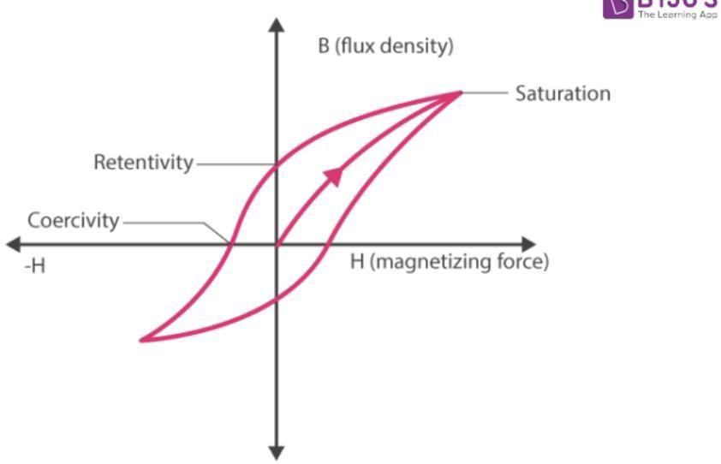

Retentivity is the magnetic flux density that remains when the magnetising force is reduced to zero.

Coercivity is the strength of the reverse magnetising field that must be applied to completely demagnetise the material.

# Curie Temperature

Ferromagnetic property depends on temperature. At a high enough temperature, ferromagnetic substances become paramagnetic. The temperature at which this transition occurs is called Curie’s temperature. It is denoted by TC.

# Uses of Ferromagnetic Materials

There are wide applications of ferromagnetic materials in the industry. They are widely used in devices like electric motors, generators, transformers, telephones, loudspeakers, and magnetic stripes on the back of credit cards.

12.a

Soft and hard magnetic materials are both essential in various applications involving magnetism and electromagnetism. The key

difference between them lies in their magnetic properties, specifically their permeability, coercivity, and ability to retain magnetization. Here, we’ll explore the characteristics, applications, and examples of both soft and hard magnetic materials.

Soft Magnetic Materials:

* 1. Characteristics:
     + High permeability: Soft magnetic materials can be easily magnetized and demagnetized, allowing them to efficiently guide magnetic flux.
     + Low coercivity: These materials require a small external magnetic field to reverse their magnetization, which makes them suitable for alternating current (AC) applications.
     + Low residual magnetism: Once the external magnetic field is removed, soft magnetic materials lose their magnetization quickly.
  2. Applications:
     + Transformers: Soft magnetic materials are used in the cores of transformers to efficiently transfer energy between primary and secondary windings.
     + Inductors and chokes: These materials are used in inductors and chokes for energy storage and filtering applications.
     + Electromagnetic cores: Soft magnetic materials are used in solenoids, relays, and other electromagnetic devices to improve performance and efficiency.

1. Examples:
   * Silicon steel: Commonly used in transformer cores due to its high permeability and low energy losses at low frequencies.
   * Soft ferrites: Suitable for high-frequency applications, such as inductors and transformers,

due to their low coercivity, high permeability, and low eddy current losses.

* + Iron-nickel alloys: These alloys, such as Permalloy and Mu-metal, offer high permeability and are used in applications requiring high magnetic shielding, such as in sensitive electronic components.

Hard Magnetic Materials:

1. Characteristics:
   * Low permeability: Hard magnetic materials are not easily magnetized or demagnetized, which allows them to maintain a stable magnetic field.
   * High coercivity: These materials require a strong external magnetic field to reverse their magnetization, making them resistant to demagnetization.
   * High residual magnetism: Once the external magnetic field is removed, hard magnetic materials retain a significant portion of their magnetization, making them suitable for permanent magnets.
2. Applications:
   * Permanent magnets: Hard magnetic materials are widely used in permanent magnets for motors, generators, and various consumer electronics.
   * Magnetic sensors: These materials are used in Hall effect sensors, magnetoresistive sensors, and other devices that detect and measure magnetic fields.
   * Data storage: Hard magnetic materials are employed in magnetic storage devices, such as hard disk drives, to store data in the form of magnetized bits.
3. Examples:
   * Alnico: An alloy of aluminum, nickel, and cobalt, Alnico offers high coercivity and is commonly used in permanent magnets for motors and loudspeakers.
   * Neodymium: Neodymium-iron-boron (NdFeB) magnets are among the strongest permanent magnets available, used in a wide range of applications, from hard disk drives to electric vehicle motors.
   * Samarium-cobalt: Samarium-cobalt (SmCo) magnets exhibit high coercivity and temperature stability, making them suitable for high- temperature and demanding applications, such as aerospace and military equipment.

In conclusion, soft and hard magnetic materials possess distinct magnetic properties that determine their suitability for different applications. Soft magnetic materials, with their high permeability and low coercivity, are ideal for electromagnetic devices and AC applications, such as transformers, inductors, and chokes. On the other hand, hard magnetic materials, with their high coercivity and residual magnetism, are perfect for permanent magnets, magnetic sensors, and data storage devices. Understanding the properties and applications of these materials allows engineers and designers to optimize the performance of various magnetic and electromagnetic systems.

13 b

13.b Various factors influencing dielectric strength

The dielectric strength of a material refers to its ability to withstand an electric field without breaking down or experiencing electrical breakdown. Several factors can influence the dielectric strength of a material. These factors include:

1. Material Type: Different materials have varying dielectric strengths. For example, materials like vacuum and gases generally have lower dielectric strengths compared to solid insulating

materials. Materials like porcelain, mica, and certain plastics have relatively high dielectric strengths.

1. Material Purity: The purity of the material is crucial. Impurities or defects in the material can create weak spots where electrical breakdown is more likely to occur. High-purity materials tend to have higher dielectric strengths.
2. Thickness: The dielectric strength of a material can be influenced by its thickness. Thicker materials are generally better at withstanding higher electric fields without breaking down.
3. Temperature: Temperature plays a significant role in dielectric strength. In general, the

dielectric strength of most materials decreases as temperature increases. Elevated temperatures can cause thermal breakdown, reducing the material's ability to insulate.

1. Frequency: Dielectric strength can also vary with the frequency of the applied electric field.

Some materials have different dielectric strengths at different frequencies. This phenomenon is important in high-frequency applications like radio frequency (RF) circuits.

1. Moisture Content: The presence of moisture or humidity in a dielectric material can

significantly reduce its dielectric strength. Moisture can create conducting paths within the material, leading to breakdown at lower electric field strengths.

1. Mechanical Stress: Mechanical stress or strain on a material can affect its dielectric strength.

Stress can cause microcracks or changes in the material's structure, making it more susceptible to electrical breakdown.

1. Voltage Waveform: The shape and characteristics of the applied voltage waveform can

impact dielectric strength. For example, pulsed or transient voltages can induce breakdown at lower voltage levels compared to continuous DC or AC voltages.

1. Frequency and Rate of Voltage Application: The rate at which voltage is applied or the

frequency of the voltage can influence dielectric strength. Rapid changes in voltage levels or high- frequency AC voltages can affect the material's ability to withstand electrical stress.

1. Aging and Environmental Factors: Over time, materials can degrade due to environmental factors such as exposure to ultraviolet (UV) light, chemicals, and radiation. These factors can reduce dielectric strength.
2. Material Geometry: The shape and geometry of the dielectric material can influence its dielectric strength. Materials with sharp edges or points are more susceptible to electrical

breakdown than those with smoother, rounded shapes.

Understanding these factors is crucial when selecting dielectric materials for specific applications, such as insulators in electrical systems or capacitors in electronic circuits. Engineers and designers must consider these factors to ensure the reliable performance of electrical and electronic devices.

14.a Analyze & discuss about various thermal & mechanical properties required for insulator

Insulators, also known as dielectric materials, play a critical role in various electrical and electronic applications by preventing the flow of electric current. To ensure their effectiveness and reliability in these applications, insulating materials must possess specific thermal and mechanical properties.

Let's analyze and discuss various properties required for insulators:

*Thermal Properties:*

1. *Thermal Conductivity:* Ideally, insulators should have low thermal conductivity. This property ensures that they do not readily transfer heat, helping to maintain a stable operating

temperature within electrical or electronic equipment. Low thermal conductivity prevents energy losses and minimizes the risk of thermal damage.

1. *Thermal Expansion:* A compatible coefficient of thermal expansion (CTE) with adjacent materials is essential to prevent stress, warping, or cracking at temperature extremes. A good

insulator should have a CTE that matches or is closely compatible with the materials it insulates.

1. *Thermal Stability:* Insulators must maintain their properties over a wide range of

temperatures. They should resist thermal degradation, such as melting, decomposition, or softening, to ensure longterm performance in various environments.

1. *Heat Resistance:* Insulating materials should be able to withstand short-term exposure to high temperatures without deteriorating. This is crucial in situations where electrical equipment may encounter brief temperature spikes due to faults or overloads.

*Mechanical Properties:*

1. *Mechanical Strength:* Insulators need to possess sufficient mechanical strength to withstand mechanical stresses, vibrations, and loads that may be applied during installation, operation, or maintenance. High tensile, compressive, and flexural strength is desirable.
2. *Hardness:* A certain degree of hardness is required to prevent surface damage, scratches, and wear over time. It helps maintain the integrity of the insulating material's surface.
3. *Flexibility:* In some applications, insulators need to be flexible to accommodate movement or deformation in the surrounding components. Flexibility can prevent the material from cracking or breaking under stress.
4. *Dielectric Strength:* This property is crucial for insulating materials, as it measures the

ability to withstand electrical stress without electrical breakdown. High dielectric strength is essential to prevent current leakage or arcing.

1. *Chemical Resistance:* Insulators should be resistant to chemical attack, as they may be exposed to various chemicals or contaminants in their operating environment. Chemical resistance ensures the material's long-term stability and reliability.
2. *Moisture Resistance:* Moisture can degrade insulating materials and reduce their dielectric properties. Insulators should have good moisture resistance to maintain their electrical insulation properties in damp or humid conditions.
3. *Creep Resistance:* Creep is the gradual deformation of a material under a constant load or stress over time. Insulators should resist creep to maintain their dimensional stability and prevent

electrical or mechanical failures.

1. *Dimensional Stability:* Insulating materials must maintain their shape and size over time, especially in high-precision applications. Minimal dimensional changes due to temperature,

moisture, or mechanical stress are crucial.

1. *Abrasion Resistance:* In applications where mechanical wear or abrasion may occur,

insulators should have good resistance to abrasion to maintain their effectiveness and longevity.

The specific thermal and mechanical properties required for insulators can vary depending on the application and operating conditions. Therefore, selecting the right insulating material involves considering these properties in conjunction with other factors such as electrical properties, cost, and environmental factors. Proper material selection ensures the safe and reliable performance of

electrical and electronic systems.

15.b Role of optoelectric materials in led & laser

Optoelectronic materials play a fundamental role in light-emitting diodes (LEDs) and lasers. These materials are essential for controlling the generation and emission of light in these devices. Here's a breakdown of the role of optoelectronic materials in LEDs and lasers:

*1. Light Emission in LEDs:*

* *Semiconductor Materials:* LEDs primarily utilize semiconductor materials, such as gallium arsenide (GaAs), gallium nitride (GaN), and indium gallium nitride (InGaN). These semiconductors are the heart of an LED and are responsible for the conversion of electrical energy into photons (light).
* *Bandgap Engineering:* Optoelectronic materials have specific bandgap energies that determine the color or wavelength of light they emit. By carefully selecting and engineering the bandgap of the semiconductor, LEDs can emit light at various wavelengths, producing different colors.
* *Electron-Hole Recombination:* When electrons and holes (missing electrons) recombine in the semiconductor material, they release energy in the form of photons. This process is the basis of light emission in LEDs.

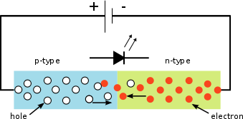

*2. Laser Emission:*

* *Active Gain Medium:* In lasers, optoelectronic materials serve as the active gain medium responsible for amplifying and generating coherent light. Common gain mediums include

semiconductor materials like GaAs, Nd:YAG (neodymium-doped yttrium aluminum garnet), and CO2 gas.

* *Population Inversion:* Achieving a population inversion in the gain medium is crucial for laser operation. This means that more atoms or molecules are in an excited state than in the ground state. Optoelectronic materials are carefully selected and prepared to facilitate population

inversion.

* *Mirrors and Cavity:* Lasers require highly reflective mirrors on either end of the gain medium to create a resonant cavity. These mirrors are often coated with dielectric materials to enhance reflectivity and control the laser's output wavelength.
* *Stimulated Emission:* When photons encounter excited electrons in the gain medium, they stimulate the emission of additional photons with the same energy and direction. This stimulated emission process leads to the coherent and monochromatic nature of laser light.

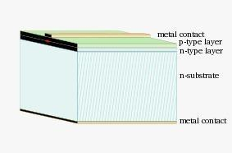

*3. Optoelectronic Properties:*

* *Direct and Indirect Bandgaps:* The type of bandgap (direct or indirect) in the optoelectronic material influences its suitability for specific applications. Direct bandgap materials are more

efficient at emitting light and are often used in LEDs, while indirect bandgap materials can be used in lasers but require more complex designs.

* *Tuning and Modulation:* Optoelectronic materials can be engineered to be tunable or modulatable,

allowing for control over the emitted light's characteristics, such as wavelength, intensity, and polarization. This is crucial for various laser applications.

In summary, optoelectronic materials are at the core of both LEDs and lasers, enabling the

conversion of electrical energy into light and the generation of coherent, intense light beams. The choice of materials and their properties plays a critical role in determining the performance and

characteristics of these optical devices. Advances in optoelectronic materials continue to drive

innovation in LED and laser technology, enabling a wide range of applications in telecommunications, healthcare, materials processing, and more.

16.a Explain about various challenges in nano electronic materials

Nano electronic materials, which involve the manipulation and utilization of materials at the nanoscale, present numerous challenges and opportunities in the field of electronics. These

challenges arise due to the unique properties and behaviors of materials at the nanoscale. Here are some of the key challenges associated with nano electronic materials:

1. Fabrication and Manufacturing:
   * Precision Fabrication: Creating nanoscale electronic components with high precision is

challenging. Techniques like electron beam lithography and atomic layer deposition must be used to achieve this level of precision.

* + **Scalability**: Transitioning from lab-scale fabrication to mass production is often difficult. Developing scalable manufacturing processes for nanoelectronics is a significant challenge.

1. Materials Selection:
   * Material Compatibility: Selecting materials that are compatible with nanoscale fabrication

techniques can be tricky. Many materials behave differently at the nanoscale, and not all of them are suitable for electronics.

* + Stability: Some nanomaterials are sensitive to environmental factors such as temperature, humidity, and radiation, making them less stable for long-term electronic applications.

1. Reliability and Durability:
   * Quantum Effects: At the nanoscale, quantum effects become prominent, leading to increased variability in device behavior. Ensuring reliability in the presence of quantum effects is a challenge.
   * Wear and Tear: Nanoscale components are susceptible to wear and tear, which can affect their performance and lifespan.
2. Integration and Interconnects:
   * Interconnect Scaling: Shrinking electronic components to the nanoscale increases resistance and capacitance in interconnects. Developing efficient interconnect solutions is a significant

challenge.

* + Heterogeneous Integration: Integrating various nanoscale components and materials into a functional device while maintaining their individual properties can be complex.

1. Power Consumption:
   * Energy Efficiency: As components become smaller and more powerful, managing power consumption becomes increasingly difficult. Leakage currents and power dissipation are significant challenges.
2. Heat Dissipation:
   * Thermal Management: Nanoscale devices generate heat in concentrated areas, making it challenging to dissipate heat effectively. Overheating can lead to device failure.
3. Quantum Effects:
   * Quantum Tunneling: At the nanoscale, quantum tunneling can occur, allowing electrons to pass

through barriers that would be insurmountable in macro-scale electronics. This can cause issues with device behavior and reliability.

1. Characterization and Testing:
   * Measurement Techniques: Traditional testing and measurement techniques are often

inadequate for nanoscale devices. Developing new, highly sensitive characterization methods is essential.

* + Defect Detection: Identifying and characterizing defects at the nanoscale is challenging but crucial for ensuring device reliability.

1. Environmental Impact:
   * Nanoparticle Toxicity: The environmental impact of manufacturing and disposing of nanoelectronic materials, especially nanoparticles, is a growing concern.
2. Regulation and Safety:
   * Safety Standards: Developing safety standards and regulations for nanoelectronic materials and devices to ensure their safe use and minimize potential health and environmental risks.

Addressing these challenges requires interdisciplinary collaboration between scientists and engineers from various fields, including materials science, physics, chemistry, and electrical engineering.

Research and innovation in these areas are essential to unlocking the full potential of nano electronic materials for next-generation electronic devices.